

**ALAGAPPA COLLEGE OF TECHNOLOGY**

**ANNA UNIVERSITY-600025**

**NM Assignment / Digital Marketing**

|  |  |  |
| --- | --- | --- |
| NAME | REG.NO | Naan Mudhalvan ID |
| HARI KRISHNAN P | 2020308012 | 9EA160F73AB7865BD034059407CA0721 |

**1. Create a blog or website using Blogpost Customize the theme design and post new article with 500 words.** 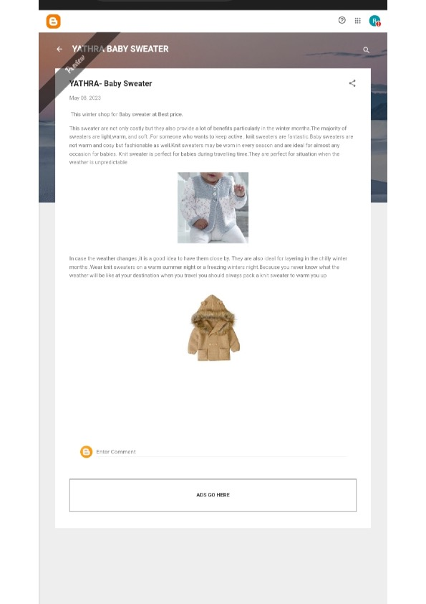

2. Create a New Facebook Business Page and post one social media poster for your brand.

https://m.facebook.com/story.php?story_fbid=337412105307126&id=100071150166663&mibextid=Nif5oz

3. Create and design a social media advertisement poster using canva.

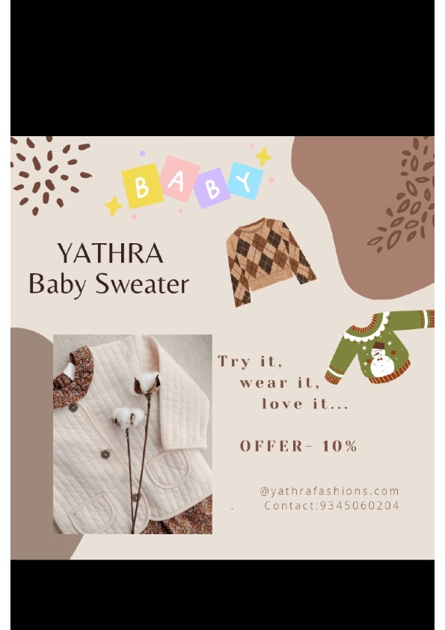

4. Create email newsletter design using MailChimp or canva tool.

